**Guess Number Higher or Lower II:**

We are playing the Guessing Game. The game will work as follows:

1. I pick a number between 1 and n.
2. You guess a number.
3. If you guess the right number, **you win the game**.
4. If you guess the wrong number, then I will tell you whether the number I picked is **higher or lower**, and you will continue guessing.
5. Every time you guess a wrong number x, you will pay x dollars. If you run out of money, **you lose the game**.

Given a particular n, return *the minimum amount of money you need to****guarantee a win regardless of what number I pick***.

**Example 1:**

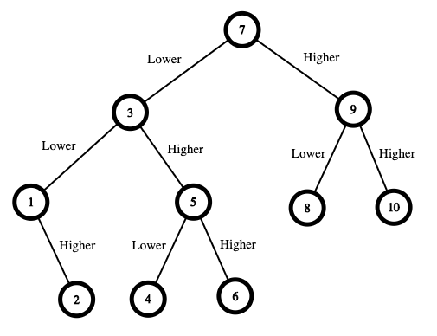

**Input:** n = 10

**Output:** 16

**Explanation:** The winning strategy is as follows:

- The range is [1,10]. Guess 7.

  - If this is my number, your total is $0. Otherwise, you pay $7.

  - If my number is higher, the range is [8,10]. Guess 9.

  - If this is my number, your total is $7. Otherwise, you pay $9.

  - If my number is higher, it must be 10. Guess 10. Your total is $7 + $9 = $16.

  - If my number is lower, it must be 8. Guess 8. Your total is $7 + $9 = $16.

  - If my number is lower, the range is [1,6]. Guess 3.

  - If this is my number, your total is $7. Otherwise, you pay $3.

  - If my number is higher, the range is [4,6]. Guess 5.

  - If this is my number, your total is $7 + $3 = $10. Otherwise, you pay $5.

  - If my number is higher, it must be 6. Guess 6. Your total is $7 + $3 + $5 = $15.

  - If my number is lower, it must be 4. Guess 4. Your total is $7 + $3 + $5 = $15.

  - If my number is lower, the range is [1,2]. Guess 1.

  - If this is my number, your total is $7 + $3 = $10. Otherwise, you pay $1.

  - If my number is higher, it must be 2. Guess 2. Your total is $7 + $3 + $1 = $11.

The worst case in all these scenarios is that you pay $16. Hence, you only need $16 to guarantee a win.

**Example 2:**

**Input:** n = 1

**Output:** 0

**Explanation:** There is only one possible number, so you can guess 1 and not have to pay anything.

**Example 3:**

**Input:** n = 2

**Output:** 1

**Explanation:** There are two possible numbers, 1 and 2.

- Guess 1.

  - If this is my number, your total is $0. Otherwise, you pay $1.

  - If my number is higher, it must be 2. Guess 2. Your total is $1.

The worst case is that you pay $1.

**Constraints:**

* 1 <= n <= 200